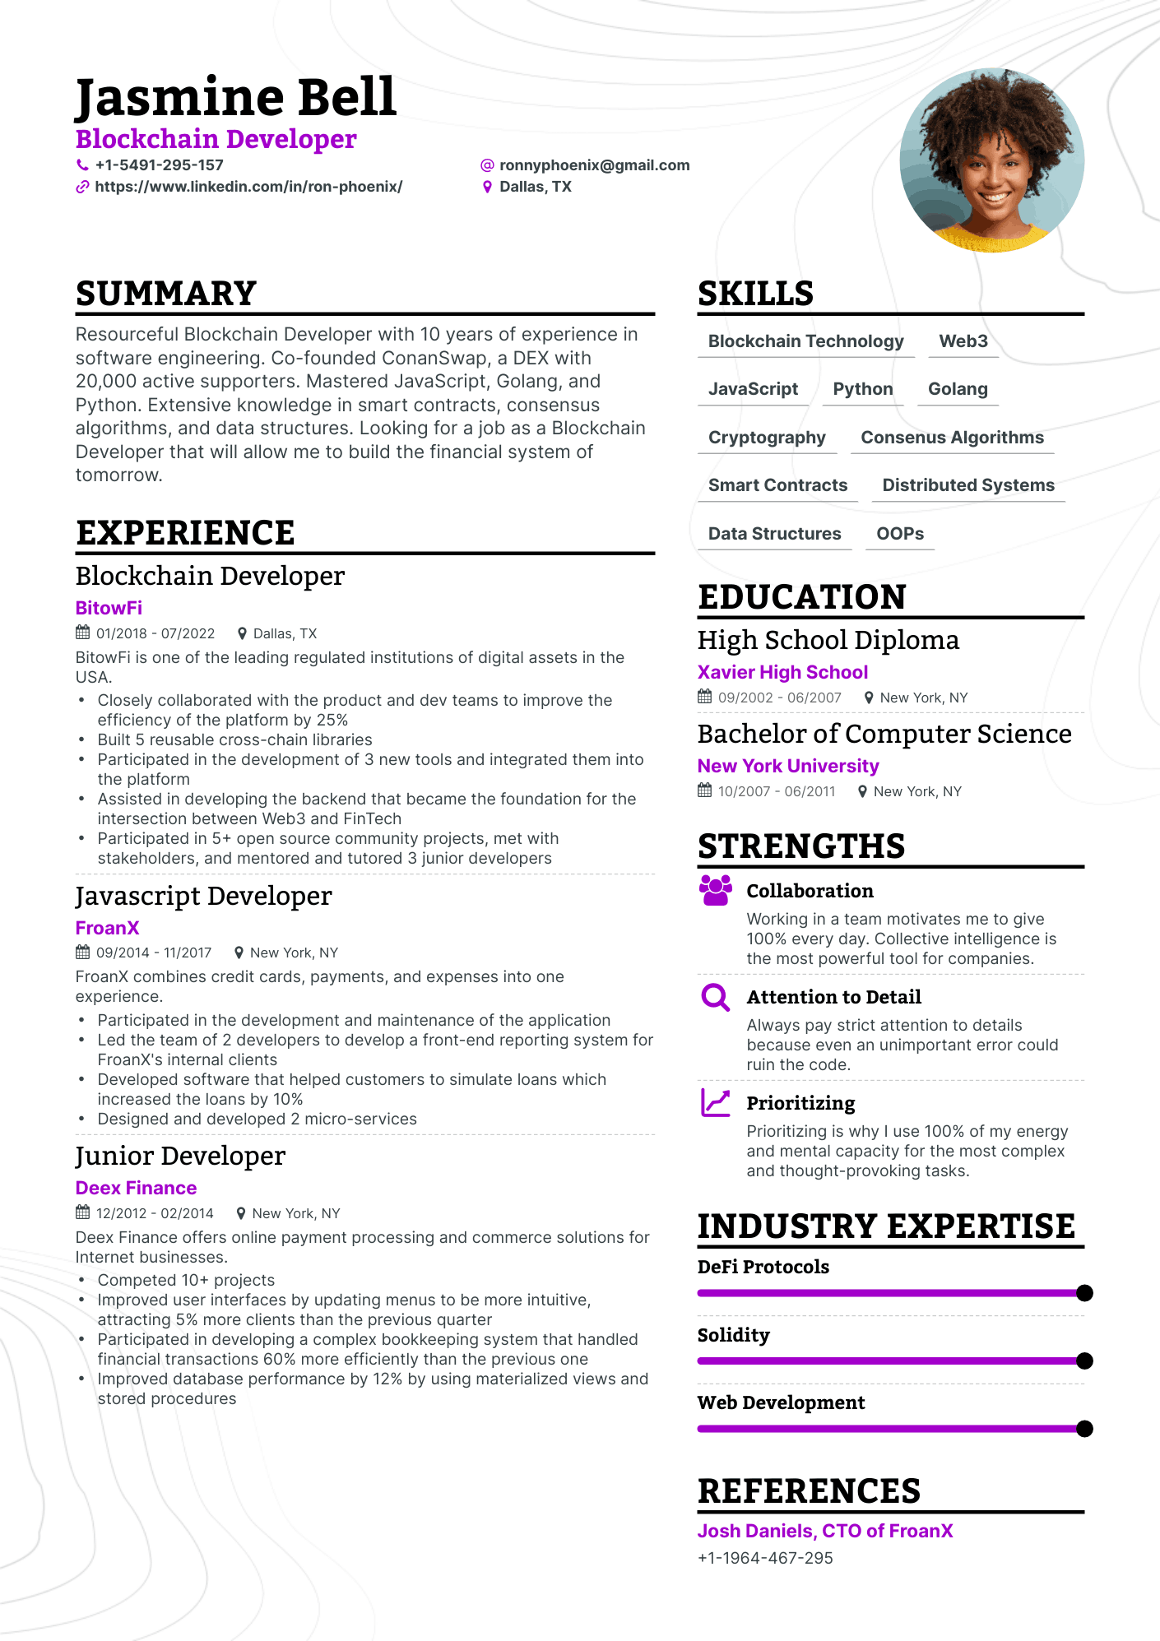
Jasmine Bell
Blockchain Developer
+1-5491-295-157
https://www.linkedin.com/in/ron-phoenix/
@ronnyphoenix@gmail.com • Dallas, TX
SUMMARY
Resourceful Blockchain Developer with 10 years of experience in software engineering. Co-founded ConanSwap, a DEX with 20,000 active supporters. Mastered JavaScript, Golang, and Python. Extensive knowledge in smart contracts, consensus algorithms, and data structures. Looking for a job as a Blockchain Developer that will allow me to build the financial system of tomorrow.
EXPERIENCE
Blockchain Developer
BitowFi
01/2018 - 07/2022
Dallas, TX
BitowFi is one of the leading regulated institutions of digital assets in the USA.
•
•
•
·
•
Closely collaborated with the product and dev teams to improve the efficiency of the platform by 25%
Built 5 reusable cross-chain libraries
Participated in the development of 3 new tools and integrated them into the platform
Assisted in developing the backend that became the foundation for the intersection between Web3 and FinTech
Participated in 5+ open source community projects, met with
stakeholders, and mentored and tutored 3 junior developers
Javascript Developer
FroanX
09/2014 11/2017
New York, NY
FroanX combines credit cards, payments, and expenses into one experience.
• Participated in the development and maintenance of the application
• Led the team of 2 developers to develop a front-end reporting system for FroanX's internal clients
Developed software that helped customers to simulate loans which increased the loans by 10%
• Designed and developed 2 micro-services
Junior Developer
Deex Finance
12/2012-02/2014
New York, NY
Deex Finance offers online payment processing and commerce solutions for Internet businesses.
SKILLS
Blockchain Technology Web3
JavaScript Python Golang
Cryptography Consenus Algorithms
Smart Contracts
Distributed Systems
Data Structures
OOPS
EDUCATION
High School Diploma Xavier High School
09/2002-06/2007
New York, NY
Bachelor of Computer Science New York University
10/2007 - 06/2011
New York, NY
STRENGTHS
Collaboration
Working in a team motivates me to give 100% every day. Collective intelligence is the most powerful tool for companies.
QAttention to Detail
Always pay strict attention to details
because even an unimportant error could ruin the code.
Prioritizing
Prioritizing is why I use 100% of my energy and mental capacity for the most complex and thought-provoking tasks.
INDUSTRY EXPERTISE
DeFi Protocols
·
Competed 10+ projects
.
Improved user interfaces by updating menus to be more intuitive, attracting 5% more clients than the previous quarter
•
Participated in developing a complex bookkeeping system that handled financial transactions 60% more efficiently than the previous one
Improved database performance by 12% by using materialized views and stored procedures
Solidity
Web Development
REFERENCES
Josh Daniels, CTO of FroanX
+1-1964-467-295

